**Machine Learning Engineer Nanodegree**

**Capstone Project**

Santhana Sankaramurthy  
December 16, 2017

**I. Definition**

**Project Overview**

This project is intended to build a machine learning algorithm to effectively detect fraud in credit card transactions. This problem space has been extensively researched and implemented in industry over the years as is evident from the work of Chan and Stolfo – Towards Scalable Learning with Non-Uniform Class and Cost Distributions: A Case Study in Credit Card Fraud Detection available at http://www.aaai.org/Papers/KDD/1998/KDD98-026.pdf

Industry estimates indicate that 0.1% of credit card transactions globally are fraudulent [Source: Wikipedia]. Increasing fraud ultimately results in increasing costs for legitimate card holders, since companies need to recoup these costs in some way. Since credit providers bear the cost of fraud, credit providers that do better at fraud detection are able to charge lesser fees to card holders and be more competitive in the marketplace, both to merchants that use these card providers as well as individual card holders.

More broadly speaking, these algorithms can be used for other imbalanced data sets that occur widely in nature and business, some of which are even more imbalanced e.g. factory production error rates (about 0.1%), server failure rates, cancer detection (0.45%), detecting oil slicks from satellite ocean images, etc.

**Problem Statement**

We will use the credit card fraud dataset available on Kaggle. This is accessible at the link - https://www.kaggle.com/dalpozz/creditcardfraud.

This consists of real data from European cardholders in 2013. The data consists of 30 total features [i.e. 28 principal components identified through PCA, transaction amount, time [elapsed since first transaction] along with the Class for each transaction - 1 indicating fraud and 0 indicating normal transaction. There are 492 frauds out of 284,807 total transactions in the data provided, hence this is a highly imbalanced dataset with the positive class amounting to only 0.172% of all transactions.

In this project, we will create an algorithm to identify which transactions are fraudulent from the given transaction set. All the transactions in the dataset provided have been labeled as being in one of two potential classes i.e. fraudulent (Class 1) or legitimate (Class 0), we will use supervised learning and specifically, classification algorithms to determine which class each transaction belongs to.

As a first step, we will examine the data set and identify any characteristics that can potentially help us define the algorithm. At this stage, we will also graph the data to examine it visually and identify any patterns. None of the features are categorical, hence none need to be converted to numerical ones before we can feed them to the classifier. We will then review the data to see if we need to do any pre-processing e.g. filling in missing values, scaling, etc.

Examples of classification algorithms that can be used are Logistic Regression, Decision Trees, Naïve Bayes, Random Forest, Simple Vector Machines and Boosting (Gradient Boosting, Ada Boost, XGBoost).

We will train a Logistic Regression Classifier to serve as the baseline. As the data is highly imbalanced, it is important to use algorithms that will work effectively with such datasets – these are Decision Trees, Random Forest and Boosting methods. Once we do the initial evaluation of the algorithms based on relative performance (based on metrics that are defined in the next section), we can identify which one is suitable for further tuning. This can be further tuned using hyper parameter optimization to improve performance further. In addition, depending on algorithm performance, we will also examine if resampling techniques can help by making the data set more balanced.

**Metrics**

We will evaluate algorithm performance by using the following metrics.

1. **AUPRC (Area Under the Precision-Recall Curve)**

Classifiers can be evaluated using the Area under the ROC curve or the Area under the Precision Recall curve. We will use the Precision Recall curve as opposed to the area under the ROC curve since the dataset is highly imbalanced and the area under the ROC curve will tend to show a high value even if the classifier is not performing particularly well). The average precision score provided by sklearn is used to compute the AUPRC.

1. **Recall**

Since we are interested in ensuring that we identify as many of the fraudulent transactions as possible (preferably all), we will use the recall accuracy. This is the number of fraudulent transactions correctly identified divided by the actual number of fraudulent transactions in the test dataset. The higher the recall accuracy, the better the classifier is able to identify all fraudulent transactions.

1. **Total Cost of Error**

The ultimate objective for the credit card provider is to use this algorithm to minimize the loss due to fraudulent transactions. In this context, a fraudulent transaction for $ 2,000 obviously costs the credit provider way more than a fraudulent transaction that costs $ 20 and we should use an algorithm that catches the larger fraudulent transactions. Measuring performance can be done by minimizing the cost of the error in the algorithm calculated as the sum of the following two numbers

* + For False Negative transactions, the loss is the transaction amount since the credit card provider incurs the loss
  + For False Positive transactions, the customer will have to prove that the transaction is legitimate and may abandon the transaction or have a negative view of the merchant/ credit provider since the transaction is flagged as fraudulent. Hence the loss can be viewed as 50% of the transaction amount (the exact percentage used i.e. 50% is an arbitrary number)

**II. Analysis**

**Data Exploration**

There are 284,807 data points with 31 variables each. Of these, 492 transactions have been identified as fraudulent.

There are 30 features available in the dataset – ‘Amount’ indicating transaction amount, ‘Time’ indicating the time elapsed since the first transaction and V1, V2…V28 – 28 other numerical features that are output by a PCA on the raw data. There are no categorical features and no missing values.

In addition, the dataset also includes the ‘Class’ feature which has a value of 1 for fraud and 0 for normal transactions – this is the target variable that is to be predicted by the algorithm.

**Exploratory Visualization**

To explore the data, we look at the fraud distribution across the two features that are provided names i.e. the Time and the Amount. The other features have names such as v1,v2… which do not provide any indication of what they refer to. The time refers to the elapsed time since the start of data collection and the ‘Amount’ refers to the value of the transaction. It will be helpful to examine the classification across these two parameters.

The distribution of fraud doesn’t show any noticeable variation across the duration of the dataset, hence the Time feature can be dropped from further analysis.

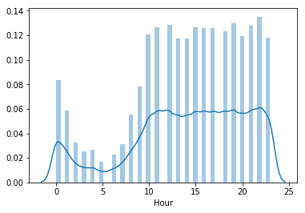

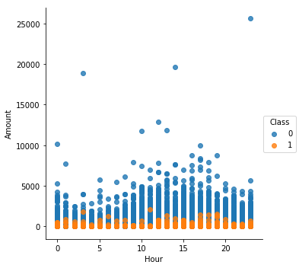

In contrast, the amount shows that the fraud is concentrated at low levels of fraud. Specifically, he highest value of ‘Amount’ for fraudulent transactions is $ 2,125.87. If all transactions above this value can probably be safely dropped, it will improve the balance of the dataset and hence improve algorithm performance. However, this rule will not generalize well beyond this particular dataset, we will keep the entire dataset as is. In addition, the cost of an error here i.e. missing a fraudulent transaction worth around $ 2,000+ will be quite high as well.

**Algorithms and Techniques**

The dataset available is clearly labeled i.e. each transaction is identified as belonging to one of two classes - ‘fraudulent’ or ‘legitimate’. Hence, this is a supervised learning problem and specifically binary classification.

We will evaluate the following algorithms for binary classification i.e. to predict if a particular transaction is legitimate [class 0] or fraudulent [class 1]

* **Logistic Regression**: Basic linear classifier
* **Decision Tree:** Uses simple decision rules to predict the class for the dataset.
* **Ensemble methods:** Random Forest, AdaBoost and XGBoost: All the boosting algorithms work by fitting the dataset to a classification algorithm (in this case, a decision tree). In the next step, the weights for the misclassified samples are increased. This continues and the final algorithm is a weighted mean of the results of the individual steps.

When fitting these algorithms, it is more important to correctly classify higher valued transactions than lower valued ones as the core objective is to minimize the weight. Hence, we will use the transaction amount as the sample weight to fit the algorithms.

In addition to these algorithms, re-sampling the dataset to improve the balance can improve algorithm performance. For example, under-sampling will create a more balanced dataset by removing legitimate transactions and keeping fraudulent transactions, so that the classifier will perform better.

This evaluation is done in two steps as follows

**Step 1: Draw the ROC and Precision Recall curves**

This provides a visual representation of the algorithm performance and indicates which ones are likely to perform better. The ROC curve plots the False Positive Rate (on the x-axis) vs. the True Positive Rate (on the y-axis) for various threshold values i.e. probabilities at which a given sample is classified as belonging to Class 0 or Class 1. The PR curve plots the Precision on the Y-axis vs. the Recall on the X-axis.

The precision-recall curve is likely to be more useful for this dataset since it is highly imbalanced. The reason is as follows - Precision is defined as True Positives divided by (True Positives + False Negatives), hence if the algorithm incorrectly classifies many transactions as legitimate i.e. as False Negatives, the denominator will increase significantly and reduce the Precision of the algorithm i.e. lower Y-value. In contrast, a high number of False Negatives (i.e. fraudulent transactions that the algorithm doesn’t classify correctly) does not directly show up in the ROC curve as we are only plotting False Positives vs. True Positives.

**Step 2: Generate Confusion Matrix, AUPRC and Recall**

We then use the confusion matrix, AUPRC and precision/recall to narrow down and identify which of the algorithms is performing the best based on the metrics identified earlier.

**Benchmark**

A benchmark model using the same dataset published on Kaggle shows a recall accuracy of 93% i.e. the model correctly identifies 93% of all fraudulent transactions in the dataset. [https:// [www.kaggle.com/joparga3/in-depth-skewed-data-classif-93-recall-acc-now](http://www.kaggle.com/joparga3/in-depth-skewed-data-classif-93-recall-acc-now)]. This will be used as the benchmark and our model should perform at or better than this to be considered successful.

**III. Methodology**

**Data Preprocessing**

We first check if there are any missing/unknown values in the dataset. A quick check of the dataset using data.keys() provides the output below.

Data columns (total 31 columns):

Time 284807 non-null float64

V1 284807 non-null float64

V2 284807 non-null float64

V3 284807 non-null float64

V4 284807 non-null float64

V5 284807 non-null float64

V6 284807 non-null float64

V7 284807 non-null float64

V8 284807 non-null float64

V9 284807 non-null float64

V10 284807 non-null float64

V11 284807 non-null float64

V12 284807 non-null float64

V13 284807 non-null float64

V14 284807 non-null float64

V15 284807 non-null float64

V16 284807 non-null float64

V17 284807 non-null float64

V18 284807 non-null float64

V19 284807 non-null float64

V20 284807 non-null float64

V21 284807 non-null float64

V22 284807 non-null float64

V23 284807 non-null float64

V24 284807 non-null float64

V25 284807 non-null float64

V26 284807 non-null float64

V27 284807 non-null float64

V28 284807 non-null float64

Amount 284807 non-null float64

Class 284807 non-null int64

Reviewing the shape of the dataset and the percentage of fraud shows the following output that matches the description provided.

0.1727 % of the dataset are fraudulent transactions

Total Value of Transactions = 25162590.01

Total Value of Fraud Transactions = 60127.97

0.2390 % is the % by value of fraudulent transactions

This indicates that all the data has been correctly imported and there that there are no missing values to be addressed during pre-processing. All the features are numerical and there are no categorical features that need to be transformed.

The following is a histogram of all the feature data provided except for Time. This shows that the ‘Amount’ is clearly on a completely different scale from the other features and must be scaled before being input to a classifier.

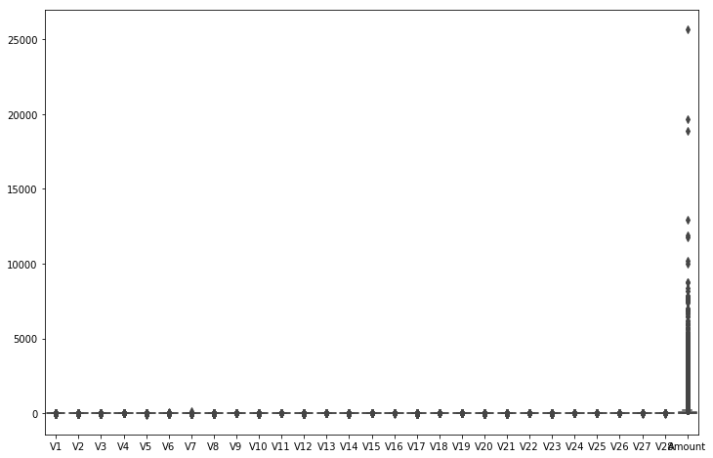

Hence, the ‘Amount’ feature is scaled using a StandardScaler.

The correlation matrix of the features is shown below. Darker shades indicate low correlation and light red shade indicate higher correlation. It is clear that the features are independent and there is virtually no correlation between features, hence all features will be retained as inputs into the algorithm.

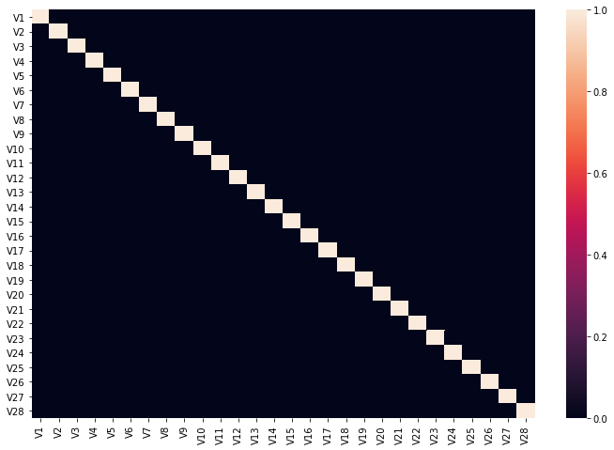

**Implementation**

The first analysis is based on an implementation of the five base algorithms and comparing the performance using the helper functions that we have defined. We will implement six-fold cross validation using the scikit-learn StratifiedKfold method. This preserves the imbalance i.e. the class representation in the folds and hence provides results that are more representative of the actual set.

The ROC curves for all the classifiers are heavily weighted towards the top left quadrant of the graph. Two of the curves (for Logistic Regression) and for XGBoost are shown below [all the plotted curves are available in the notebook]. As expected, the curves do not show much of a difference with the Area under the ROC curve (averaged over the 6 folds) being 0.9604 for Logistic Regression and 0.9710 (for XG Boost).

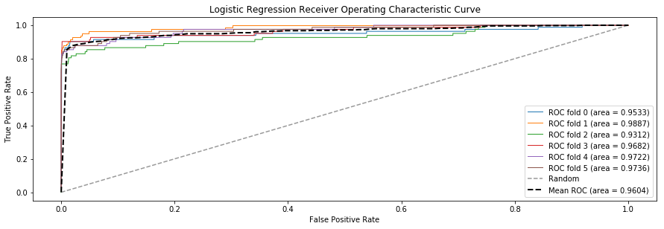

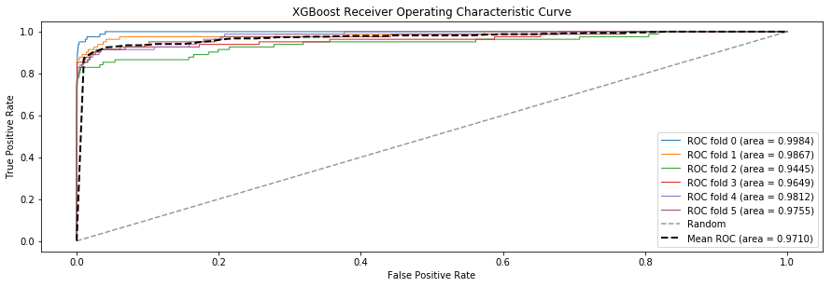

We now turn to the PR curves for the five algorithms which are provided below.

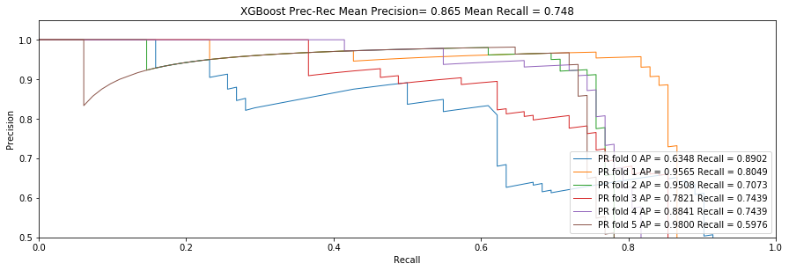

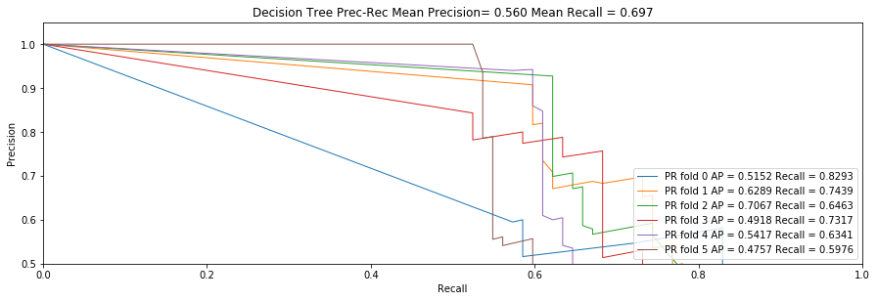

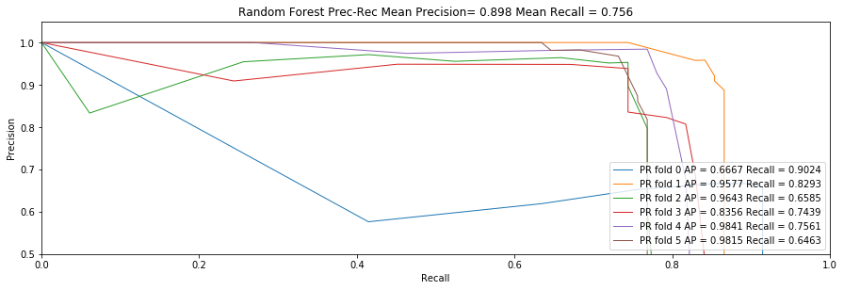

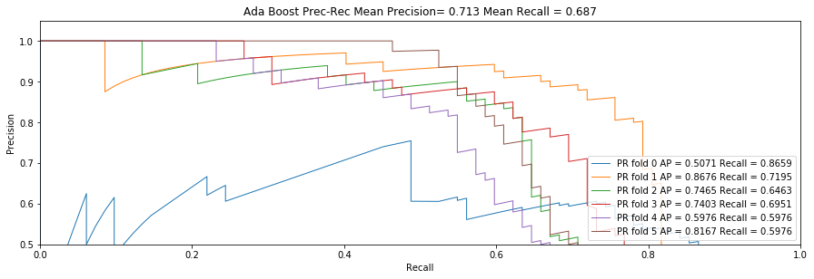

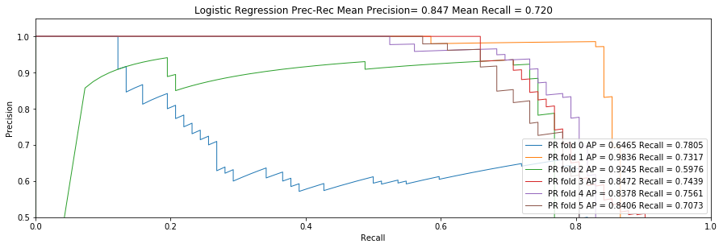

An examination of the above shows the following

* Decision Tree, AdaBoost and Logistic Regression show generally lower PR curves (and hence lesser AUPRC) compared to XGBoost and Random Forest.
* Mean Precision and Recall are highest for the boosting methods
* All the algorithms (except perhaps for XG Boost) are showing that for the first fold, the PR line indicates low precision and low recall. This means the algorithm is performing poorly on a particular fold of the dataset.

These indicate that XG Boost and Random Forest are likely to perform better for our purposes.

The execution time of these algorithms to perform the cross-validation and draw the PR and ROC curves is provided below. This indicates that XGBoost takes significantly longer to execute compared to the other algorithms.

|  |  |
| --- | --- |
| Algorithm | Execution Time (in seconds) |
| Logistic Regression | 107.62 |
| Decision Tree | 298.45 |
| Ada Boost | 864.78 |
| XG Boost | 1936.29 |
| Random Forest | 271.44 |

We next calculate confusion matrices, precision and recall values and the total error cost to make a final determination of the algorithm to be used for further analysis and tuning.

Compared to prior implementations, there is additional code here is to calculate the total error cost which is computed as per metric definitions indicated earlier i.e. cost of all false negative transactions + 50% of cost of false positives.

Average Precision, Recall, F-Score and Error Cost are shown below for the five algorithms.

|  |  |  |  |  |  |
| --- | --- | --- | --- | --- | --- |
| Algorithm | Average Precision | Recall | Cost of False Negatives ($) | Cost of False Positives ($) | Total Error Cost ($) |
| Logistic Regression | 0.7621 | 0.9991 | 8,420.42 | 481.59 | 8,902.01 |
| Decision Tree | 0.5600 | 0.8071 | 4,658.37 | 995.00 | 5,653.36 |
| Ada Boost | 0.7840 | 0.9993 | 3,256.93 | 1,204.05 | 4,460.99 |
| XG Boost | 0.8754 | 0.9996 | 3,738.36 | 634.63 | 4,372.99 |
| Random Forest | 0.8373 | 0.9995 | 6,536.21 | 123.41 | 6,659.62 |

Based on the above data, we can draw the following conclusions

* Logistic Regression and Decision Trees are performing well from an execution time perspective, however average precision, recall accuracy and error costs indicate they are not a good fit for this dataset.
* Random Forest is performing the best from the average precision and recall perspectives. It is also relatively very fast. However, the cost of the error is high, indicating that while it is missing fewer transactions, the ones it is missing are relatively more expensive.
* AdaBoost is doing well with the lowest total error cost, however it has lower average precision and slightly lower recall compared to XGBoost.
* The execution time of XGBoost is significantly higher compared to AdaBoost i.e. 2.2 times execution time.
* XGBoost has better average precision and better recall compared to AdaBoost, though it has higher cost and longer execution time. Hence, there is a tradeoff between using a more complex algorithm to achieve better average precision and accuracy. Hence, we will use XGBoost for further analysis and tuning to improve performance.
* Lastly, the recall is above 0.999 i.e. above 99.9% for 4 of the five algorithms considered, which is better than the benchmark. Hence, the objective of further refinement will be to increase the average precision (which represents the area under the precision-recall curve) and reduce the total error cost to be as close to zero as possible.

**Refinement**

Our objectives in tuning the algorithm are to increase the average precision and recall, while decreasing the total cost of error. The initial (untuned XGBoost) performance metrics are as follows.

Base XGBoost

Average Precision = 0.8754

precision recall f1-score support

Legit 0.9997 0.9999 0.9998 56864

Fraud 0.9639 0.8163 0.8840 98

avg / total 0.9996 0.9996 0.9996 56962

Total_fn_loss = $ 3738.36

Total_fp_loss = $ 634.63

Total cost of error = $ 4372.99

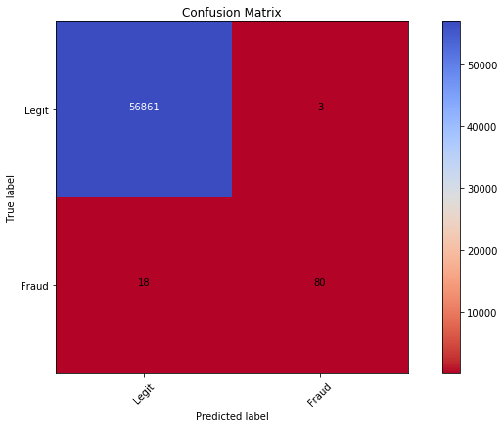

We train the algorithm with an initial set of parameters. The initial parameters used are as follows. The objective is binary: logistic since this is a binary classification problem.

ind_params = {'learning_rate': 0.1, 'n_estimators': 300, 'random_state':0, 'subsample': 0.8, 'colsample_bytree': 0.8, 'objective': 'binary:logistic'}

The scoring mechanism used for tuning XGBoost is the roc_auc which may not be ideal, for the reasons discussed earlier. A custom scorer that incorporates the error cost will probably yield better results.

We will use the RandomizedSearch from sklearn instead of GridSearch since it randomly selects the combinations to search (instead of an exhaustive search of all combinations) and may be much faster. [Reference: http://blog.kaggle.com /2015/07/16/scikit-learn-video-8-efficiently-searching-for-optimal-tuning-parameters/]

cv_params = {'max_depth': [3,5,7], 'min_child_weight': [1,3,5]}

This search provides the results shown below.

params': [{'max_depth': 3, 'min_child_weight': 1},

{'max_depth': 5, 'min_child_weight': 1},

{'max_depth': 5, 'min_child_weight': 5},

{'max_depth': 5, 'min_child_weight': 3},

{'max_depth': 7, 'min_child_weight': 3},

{'max_depth': 3, 'min_child_weight': 3},

{'max_depth': 7, 'min_child_weight': 1},

{'max_depth': 3, 'min_child_weight': 5}],

'rank_test_score': array([4, 7, 6, 1, 8, 2, 5, 3], dtype=int32)

Hence, the following combination yields best results with a roc_auc score of 0.99999834 - max_depth': 5, 'min_child_weight': 3

We then turn to tuning the learning rate and subsample. The possible values fed into the RandomizedSearch are as follows.

cv_params = {'learning_rate': [0.2, 0.1, 0.01], 'subsample': [0.7,0.8,0.9]}

We then get the following results indicating that a learning rate of 0.1 and a subsample of 0.7 performs the best.

params': [{'learning_rate': 0.2, 'subsample': 0.7},

{'learning_rate': 0.1, 'subsample': 0.7},

{'learning_rate': 0.2, 'subsample': 0.8},

{'learning_rate': 0.1, 'subsample': 0.8},

{'learning_rate': 0.01, 'subsample': 0.8},

{'learning_rate': 0.1, 'subsample': 0.9},

{'learning_rate': 0.01, 'subsample': 0.7},

{'learning_rate': 0.01, 'subsample': 0.9}],

'rank_test_score': array([5, 2, 4, 1, 7, 3, 6, 8], dtype=int32),

To summarize, we have found the following parameters through tuning

* Max Depth – 5
* Min Child Weight – 3
* Learning Rate (eta) – 0.1
* Subsample – 0.7

We then use the cv function provided within the xgboost boost API itself. This uses early stopping to determine the best parameters without overfitting. The API requires us to create a DMatrix from the test data, which helps make the algorithm more efficient with a larger training set.

When we look at the results of the cv search below, we see that iteration 123 provides best results.

|  |  |  |  |  |
| --- | --- | --- | --- | --- |
|  | **test-auc-mean** | **test-auc-std** | **train-auc-mean** | **train-auc-std** |
| **114** | 0.979502 | 0.009407 | 0.999553 | 0.000114 |
| **115** | 0.979580 | 0.009653 | 0.999576 | 0.000119 |
| **116** | 0.979779 | 0.009119 | 0.999609 | 0.000116 |
| **117** | 0.979906 | 0.008913 | 0.999624 | 0.000120 |
| **118** | 0.979634 | 0.009318 | 0.999652 | 0.000101 |
| **119** | 0.979459 | 0.009361 | 0.999657 | 0.000095 |
| **120** | 0.979371 | 0.009414 | 0.999666 | 0.000092 |
| **121** | 0.979821 | 0.009319 | 0.999676 | 0.000087 |
| **122** | 0.979926 | 0.008866 | 0.999681 | 0.000082 |
| **123** | 0.979973 | 0.008758 | 0.999692 | 0.000081 |

We use this iteration to evaluate the average precision, recall and total cost of error for the tuned classifier. The results we obtain are as follows.

|  |  |  |  |  |  |
| --- | --- | --- | --- | --- | --- |
| Algorithm | Average Precision | Recall | Cost of False Negatives ($) | Cost of False Positives ($) | Total Error Cost ($) |
| Base XG Boost | 0.8754 | 0.9996 | 3,738.36 | 634.63 | 4,372.99 |
| Tuned XG Boost | 0.8863 | 0.9996 | 4,023.69 | 60.99 | 4,084.68 |

The associated feature importance graph is below, which indicates that V14,V4 and V17 are the features that have the most impact on the model. Since these are PCA features and we don’t have access to the underlying ‘real-life’ features, we are unable to draw further conclusions.

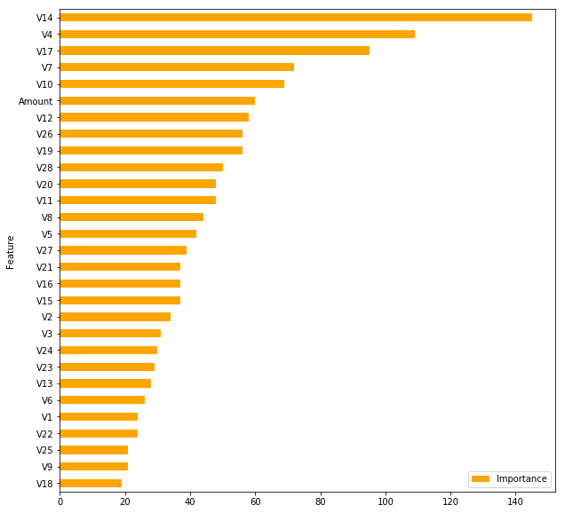

**IV. Results**

**Model Evaluation and Validation**

Based on these results, we determine that the tuned XGBoost model performs extremely well against this and achieves a very low total error cost, very high precision and recall accuracy as shown above.

To view the performance in a different light, Total value of transactions in the dataset = $ 25,162,590 and the total value of fraudulent transactions = $ 60,128

**Total cost of error of the algorithm = $ 4,084 i.e. 6.7% of the fraudulent transactions and 1.6% of the total transactions processed.**

**V. Conclusion**

**Reflection I: Hyper-parameter Tuning**

Hyper-parameter tuning for XGBoost turned out to be arduous in terms of execution time since each run with GridSeach took a fairly long time. I found that Randomized Search executes faster – while it may still not find the absolute best parameters, it is sufficient for our purposes and executes in a time of 1 hour 15 minutes or so.

**Reflection II: Data Quality**

Secondly, the dataset available for the project is clean and well-labeled, requiring minimal pre-processing before input. It is unlikely that such well-formed data will be available in the real-world, hence I anticipate that production scenarios will require significantly more work on the dataset before training and evaluating classifiers.

**Improvement**

There are two areas of improvement identified, one is to use sampling methods and second, to consider alternative classifiers that execute faster than XGBoost.

**Sampling Methods:**

One of the key observations throughout the project is that many issues with classifier performance stem from having a huge class imbalance in the dataset. In this context, researchers have developed resampling techniques that can help reduce the imbalance of the dataset and hence improve performance. The family of techniques considered here are the imbalanced-learn methods [API and documentation is available at <http://contrib.scikit-learn.org/imbalanced-learn/stable/api.html>] Usage of these methods was described at PyData 2016 [accessible at <https://www.youtube.com/watch?v=-Z1PaqYKC1w>].

We evaluate the performance of the base XGBoost classifier against these sampling methods to determine if there is an improvement in performance. This shows the following results.

OverSampler

-------------

Precision Score = 0.9959

Recall Score = 1.0000

F Beta Score = 0.9967

Total_fn_loss = $ 0.00

Total_fp_loss = $ 15327.61

Total cost of error = $ 15327.61

UnderSampler

-------------

Precision Score = 0.9636

Recall Score = 0.8833

F Beta Score = 0.9464

Total_fn_loss = $ 784.90

Total_fp_loss = $ 521.72

Total cost of error = $ 1306.61

**NearMiss**

**-------------**

**Precision Score = 1.0000**

**Recall Score = 0.9917**

**F Beta Score = 0.9983**

**Total_fn_loss = $ 0.76**

**Total_fp_loss = $ 0.00**

**Total cost of error = $ 0.76**

SMOTE ENN

-------------

Precision Score = 0.9926

Recall Score = 0.9848

F Beta Score = 0.9911

Total_fn_loss = $ 84964.72

Total_fp_loss = $ 27396.14

Total cost of error = $ 112360.86

These results demonstrate that the NearMiss sampling method vastly improves algoritm performance with a high recall, 100% precision and low error cost. This can be an area for further exploration to improve performance even further. Given that we have already exceeded the benchmark results, this is not explored further in this report.

**Execution Time:**

During the analysis, it is observed that XGBoost performs well and generates good results. However, it does take significantly longer to execute compared to other algorithms. This can be a serious limitation in the context of real-world datasets with larger sample sizes. Hence reducing execution time should be considered while identifying the algorithm. During our analysis, we found that AdaBoost can be tuned and generate good results in less than half the time for XGBoost. A brief search of the internet also shows that there are newer algorithms such as LightGBM and CatBoost, further variations on XGBoost that have emerged. It will be worthwhile to examine these to see if these execute faster and deliver as good or better results.

**Appendix: List of references (not mentioned in the text)**

* <https://jessesw.com/XG-Boost/>
* <https://www.analyticsvidhya.com/blog/2016/03/complete-guide-parameter-tuning-xgboost-with-codes-python/>
* <https://www.kaggle.com/lct14558/imbalanced-data-why-you-should-not-use-roc-curve>